**Solving Simple Problems in C**

**Lab 3**

**Section M**

**Submitted by:**

**Haadi-Mohammad Majeed**

**Submission Date**

**September 21, 2018**

**Date**

**September 16, 2018**

**Lab Problem**

The primary objective of lab 3 is to learn how to funnel the outputs of the controller and use them in code, along with creating basic functions utilizing inputs and returning modified values.

**Analysis**

The lab is parsed into 4, with 75% of them working with the creation and usage of methods, while all are utilizing the outputs of ds4rd.exe. The parts created have some synergy between each other.

**Design**

Part one of the lab consists of formatting the output of ds4rd executable, with the accelerations of each dimension shown with the time in seconds, with seconds having 8 characters allocated with 3 decimal places, and the accelerations having a 7 char allocation with 4 decimal places.

Part two requests that a function be made defined as mag. Mag is to intake the 3 accelerations and return the overall magnitude of them. It also requires the importation of the math library as to use exponents more efficiently.

Part three, upon completion, results in an additional 3 functions each which calculate the time based on the milliseconds, in minutes, seconds and milliseconds. It requires the usage for modulus and standard division to successfully achieve the correct results.

Part four constitutes the creation of a program that takes the output of ds4re.exe and throws it into a newly formed method to return how many of the 4 primary buttons are being pressed at that instant and return that into console.

**Testing**

**Part 1**

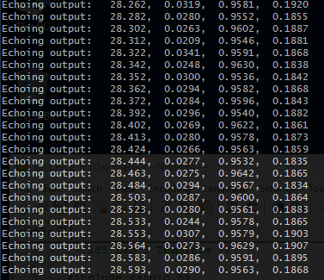

This code consisted of a printf statement that outputs seconds, and the 3 accelerations all to be formatting in such a particular fashion

**Part 2**

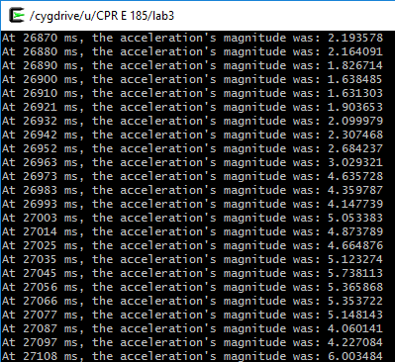

The instructions were to create a method to calculate the magnitude of the overall acceleration, thus by creating the prototype and function, it was infinitely looped.

**Part 3**

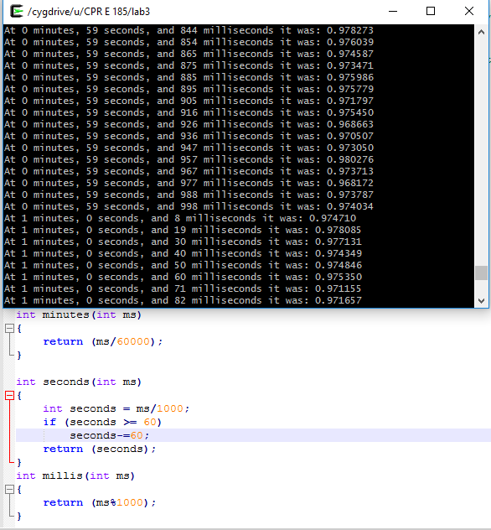

Requested the creation of the methods:

* Minutes(int ms)
* Seconds(int ms)
* Millis(int ms)

All which would return their respective amount based on the millisecond input

**Part 4**

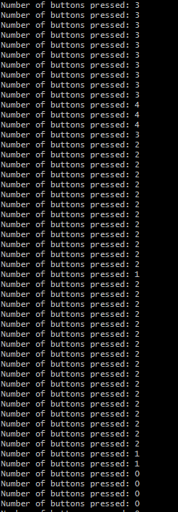

This part of the code used the –b part of the controller input commands to get the button binary value of on or off. Adding up the values resulted in the number of buttons currently toggled

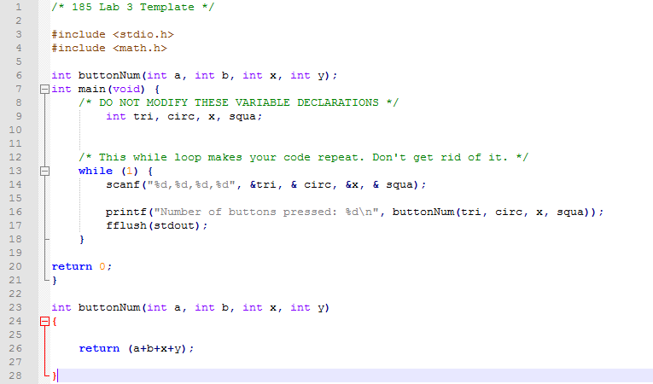

**Comments**

Prototypes are parts of code that should be in front of main unless you code the entire function above main, which may be better for code efficiency. Initially, forgetting the prototype had caused some error, but upon introducing them into the code, there was no issue.

**Implementation**

**Part 1-3**

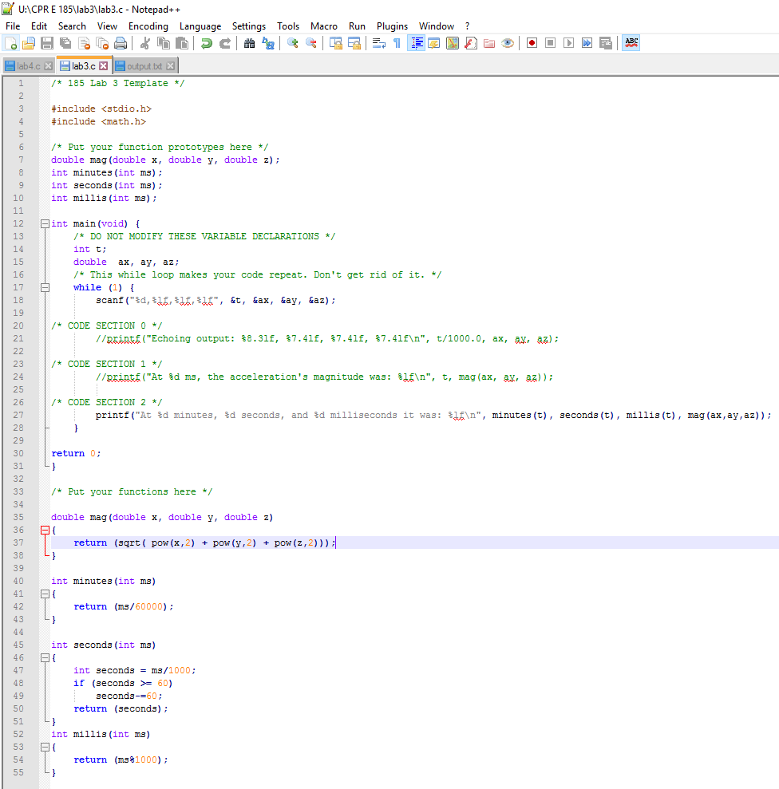

**Part 4**